EXCHANGE INTERACTION

Magnetism can be divided into two groups, group A and group B. In group A there is no interaction between the individual moments and each moment acts independently of the others. Diamagnets and paramagnets belong to this group.
Group B consists of the magnetic materials most people are familiar with, like iron or nickel. Magnetism occurs in these materials because the magnetic moments couple to one another and form magnetically ordered states. The coupling, which is quantum mechanical in nature, is known as the exchange interaction and is rooted in the overlap of electrons in conjunction with Pauli's exclusion principle. Whether it is a ferromagnet, antiferromagnet of ferrimagnet the exchange interaction between the neighboring magnetic ions will force the individual moments into parallel (ferromagnetic) or antiparallel (antiferromagnetic) alignment with their neighbours. The three types of exchange which are currently believed to exist are, a) direct exchange, b) indirect exchange and c) superexchange.

A. Direct exchange

Direct exchange operates between moments, which are close enough to have sufficient overlap of their wavefunctions. It gives a strong but short range coupling which decreases rapidly as the ions are separated. An initial simple way of understanding direct exchange is to look at two atoms with one electron each. When the atoms are very close together the Coulomb interaction is minimal when the electrons spend most of their time in between the nuclei. Since the electrons are then required to be at the same place in space at the same time, Pauli's exclusion principle requires that they possess opposite spins. According to Bethe and Slater the electrons spend most of their time in between neighboring atoms when the interatomic distance is small. This gives rise to antiparallel alignment and therefore negative exchange. (antiferromagnetic), Fig. 1.

Fig. 1. Antiparallel alignment for small interatomic distances.

If the atoms are far apart the electrons spend their time away from each other in order to minimize the electron-electron repulsion. This gives rise to parallel alignment or positive exchange (ferromagnetism), Fig. 2.

Fig. 2. Parallel alignment for large interatomic distances.

For direct inter-atomic exchange j can be positive or negative depending on the balance between the Coulomb and kinetic energies. The Bethe-Slater curve represents the magnitude of direct exchange as a function of interatomic distance. Cobalt is situated near the peak of this curve, while chromium and manganese are on the side of negative exchange. Iron, with its sign depending on the crystal structures probably around the zero-crossing point of the curve, Fig. 3.

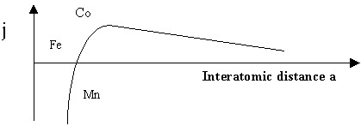

Fig. 3. The Bethe-Slater curve.

B. Indirect exchange

Indirect exchange couples moments over relatively large distances. It is the dominant exchange interaction in metals, where there is little or no direct overlap between neighboring electrons. It therefore acts through an intermediary, which in metals are the conduction electrons (itinerant electrons). This type of exchange is better known as the RKKY interaction named after Ruderman, Kittel, Kasuya and Yoshida. The RKKY exchange coefficient j oscillates from positive to negative as the separation of the ion changes and has the damped oscillatory nature shown in Fig. 7. Therefore depending on the separation between a pair of ions their magnetic coupling can be ferromagnetic or antiferromagnetic. A magnetic ion induces a spin polarization in the conduction electrons in its neighborhood. This spin polarization in the itinerant electrons is felt by the moments of other magnetic ions within the range leading to an indirect coupling.
In rare-earth metals, whose magnetic electrons in the 4f shell are shielded by the 5s and 5p electrons, direct exchange is rather and indirect exchange via the conduction electrons gives rise to magnetic order in these materials.

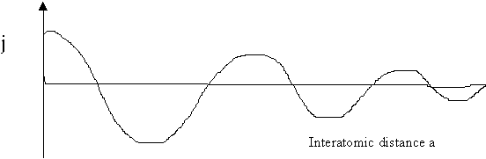

Fig. 7. The coefficient of indirect (RKKY) exchange versus the interatomic spacing a.

C. Superexchange

Superexchange describes the interaction between moments on ions too far apart to be connected by direct exchange, but coupled over a relatively long distance through a non-magnetic material. We take as an example the coupling between the moments on a pair of metal cations separated by a diatomic anion as illustrated in Fig.8. The ferric ion has a half filled 3d shell and so has a spherically symmetric charge distribution (S state ion). The triply rare-earth ion is not symmetric and has a strong spin-orbit coupling; its charge distribution is coupled to its moment. The ion's moments are coupled via superexchange, so turning the Fe moment alters the overlap of the R cation in the molecule. This changes the magnitude of both the Coulomb and exchange interactions between the cations, leading to a coupling, which depends on the moment's orientation.

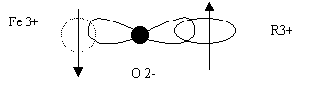
Fig. 8. Superexchange in ferric-rare earth interaction in a garnet.

